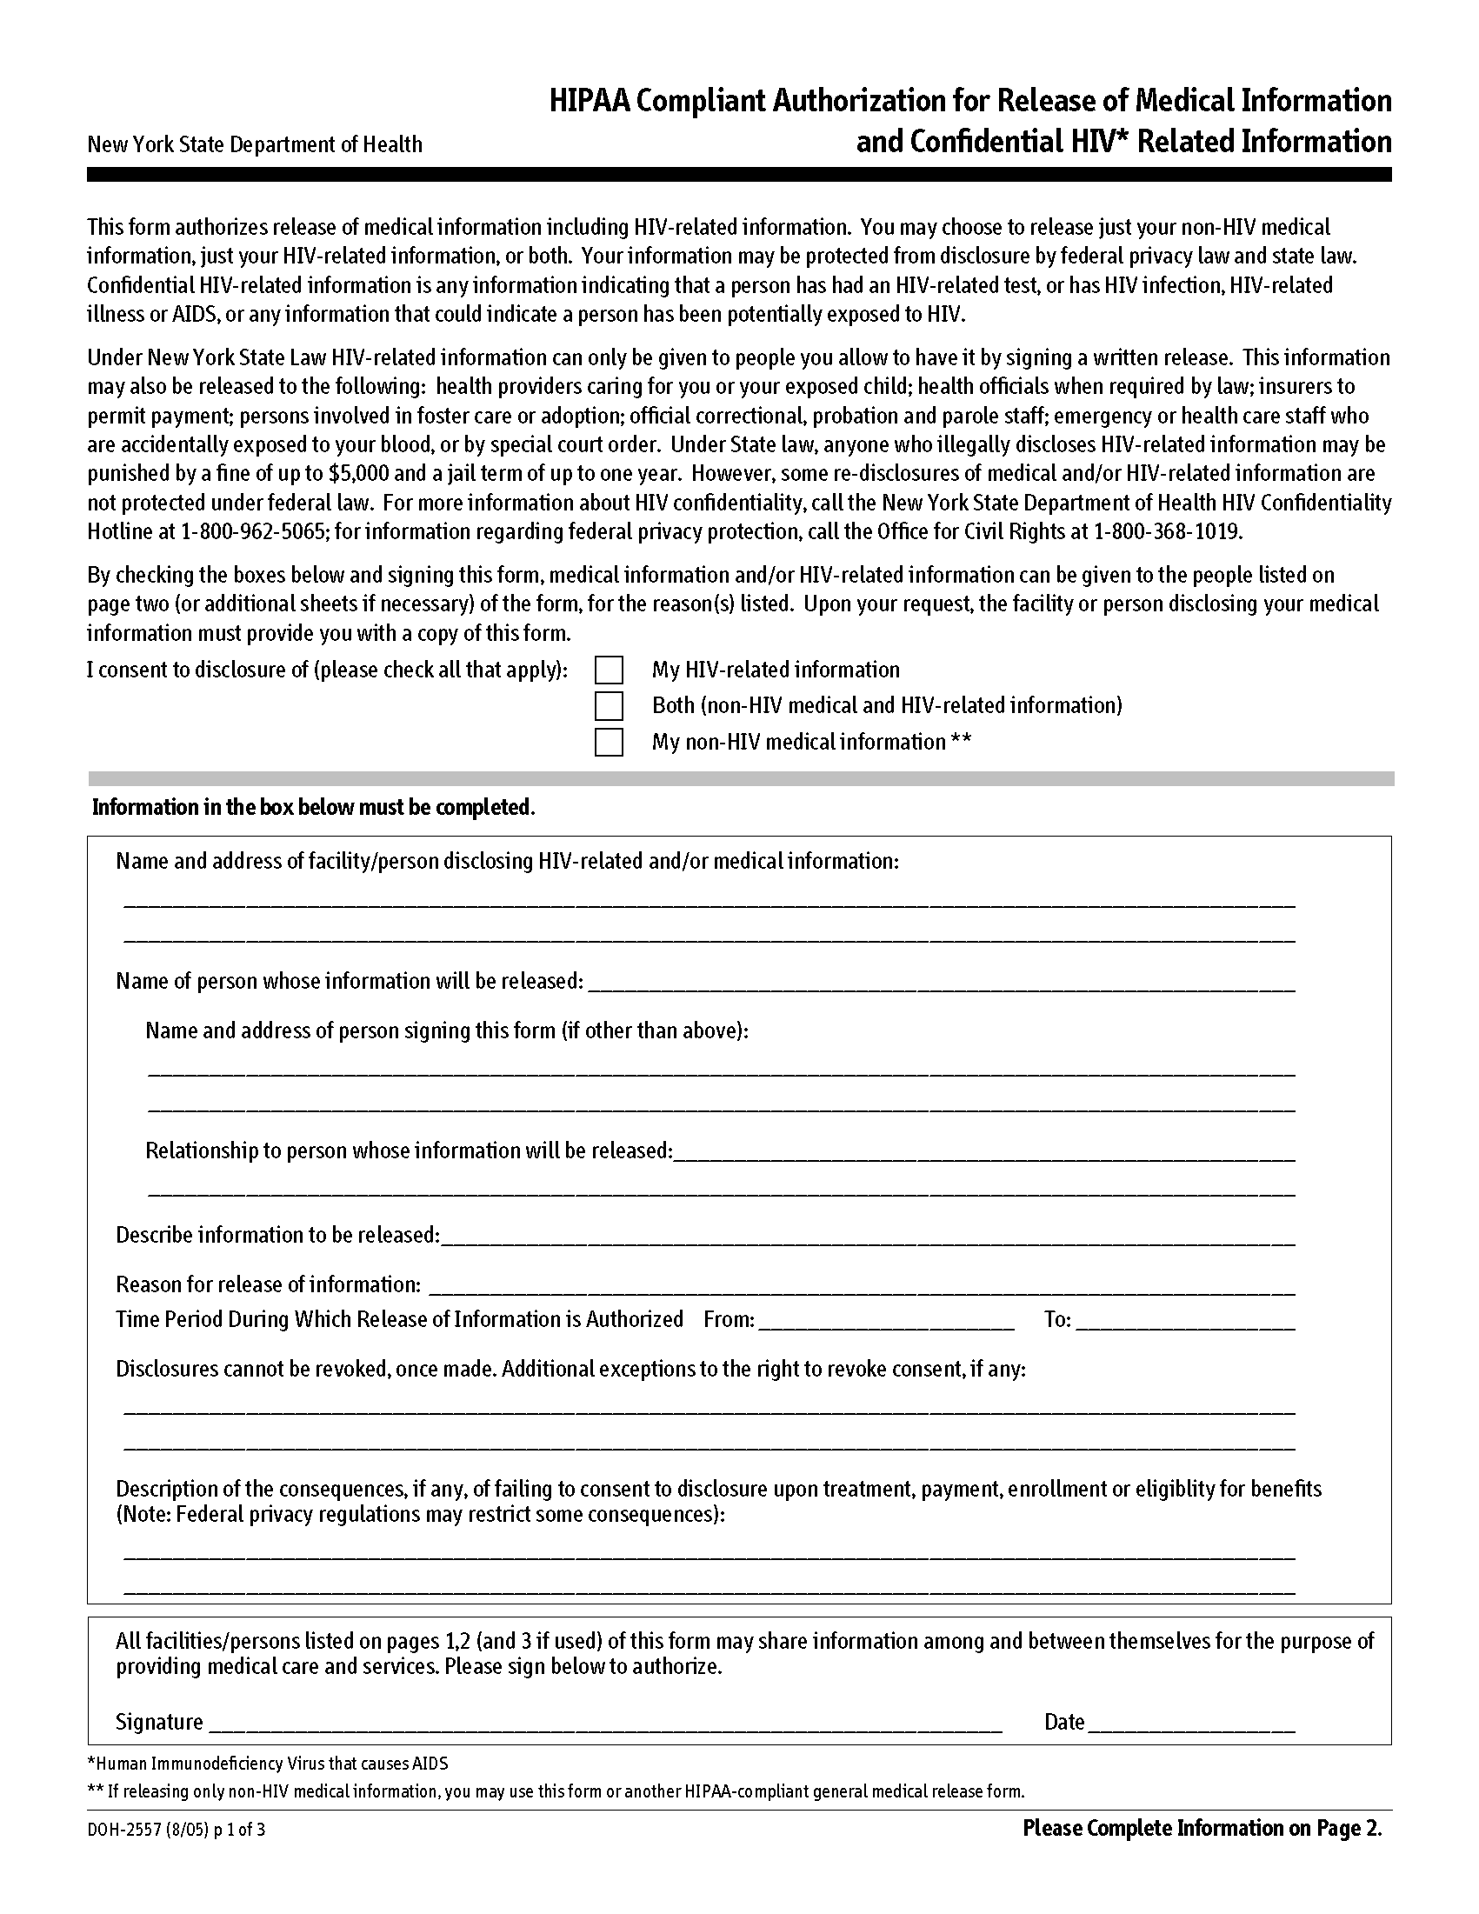
Order No. 01-12345 - 003
Karen Marcetti
William Beaumont Hospital - Royal Oak, 3601 West 13 Mile Road, Royal Oak, MI 48073

Any and All Records
Present

12/22/1965
Marcetti v. Barkel, M.D.
X
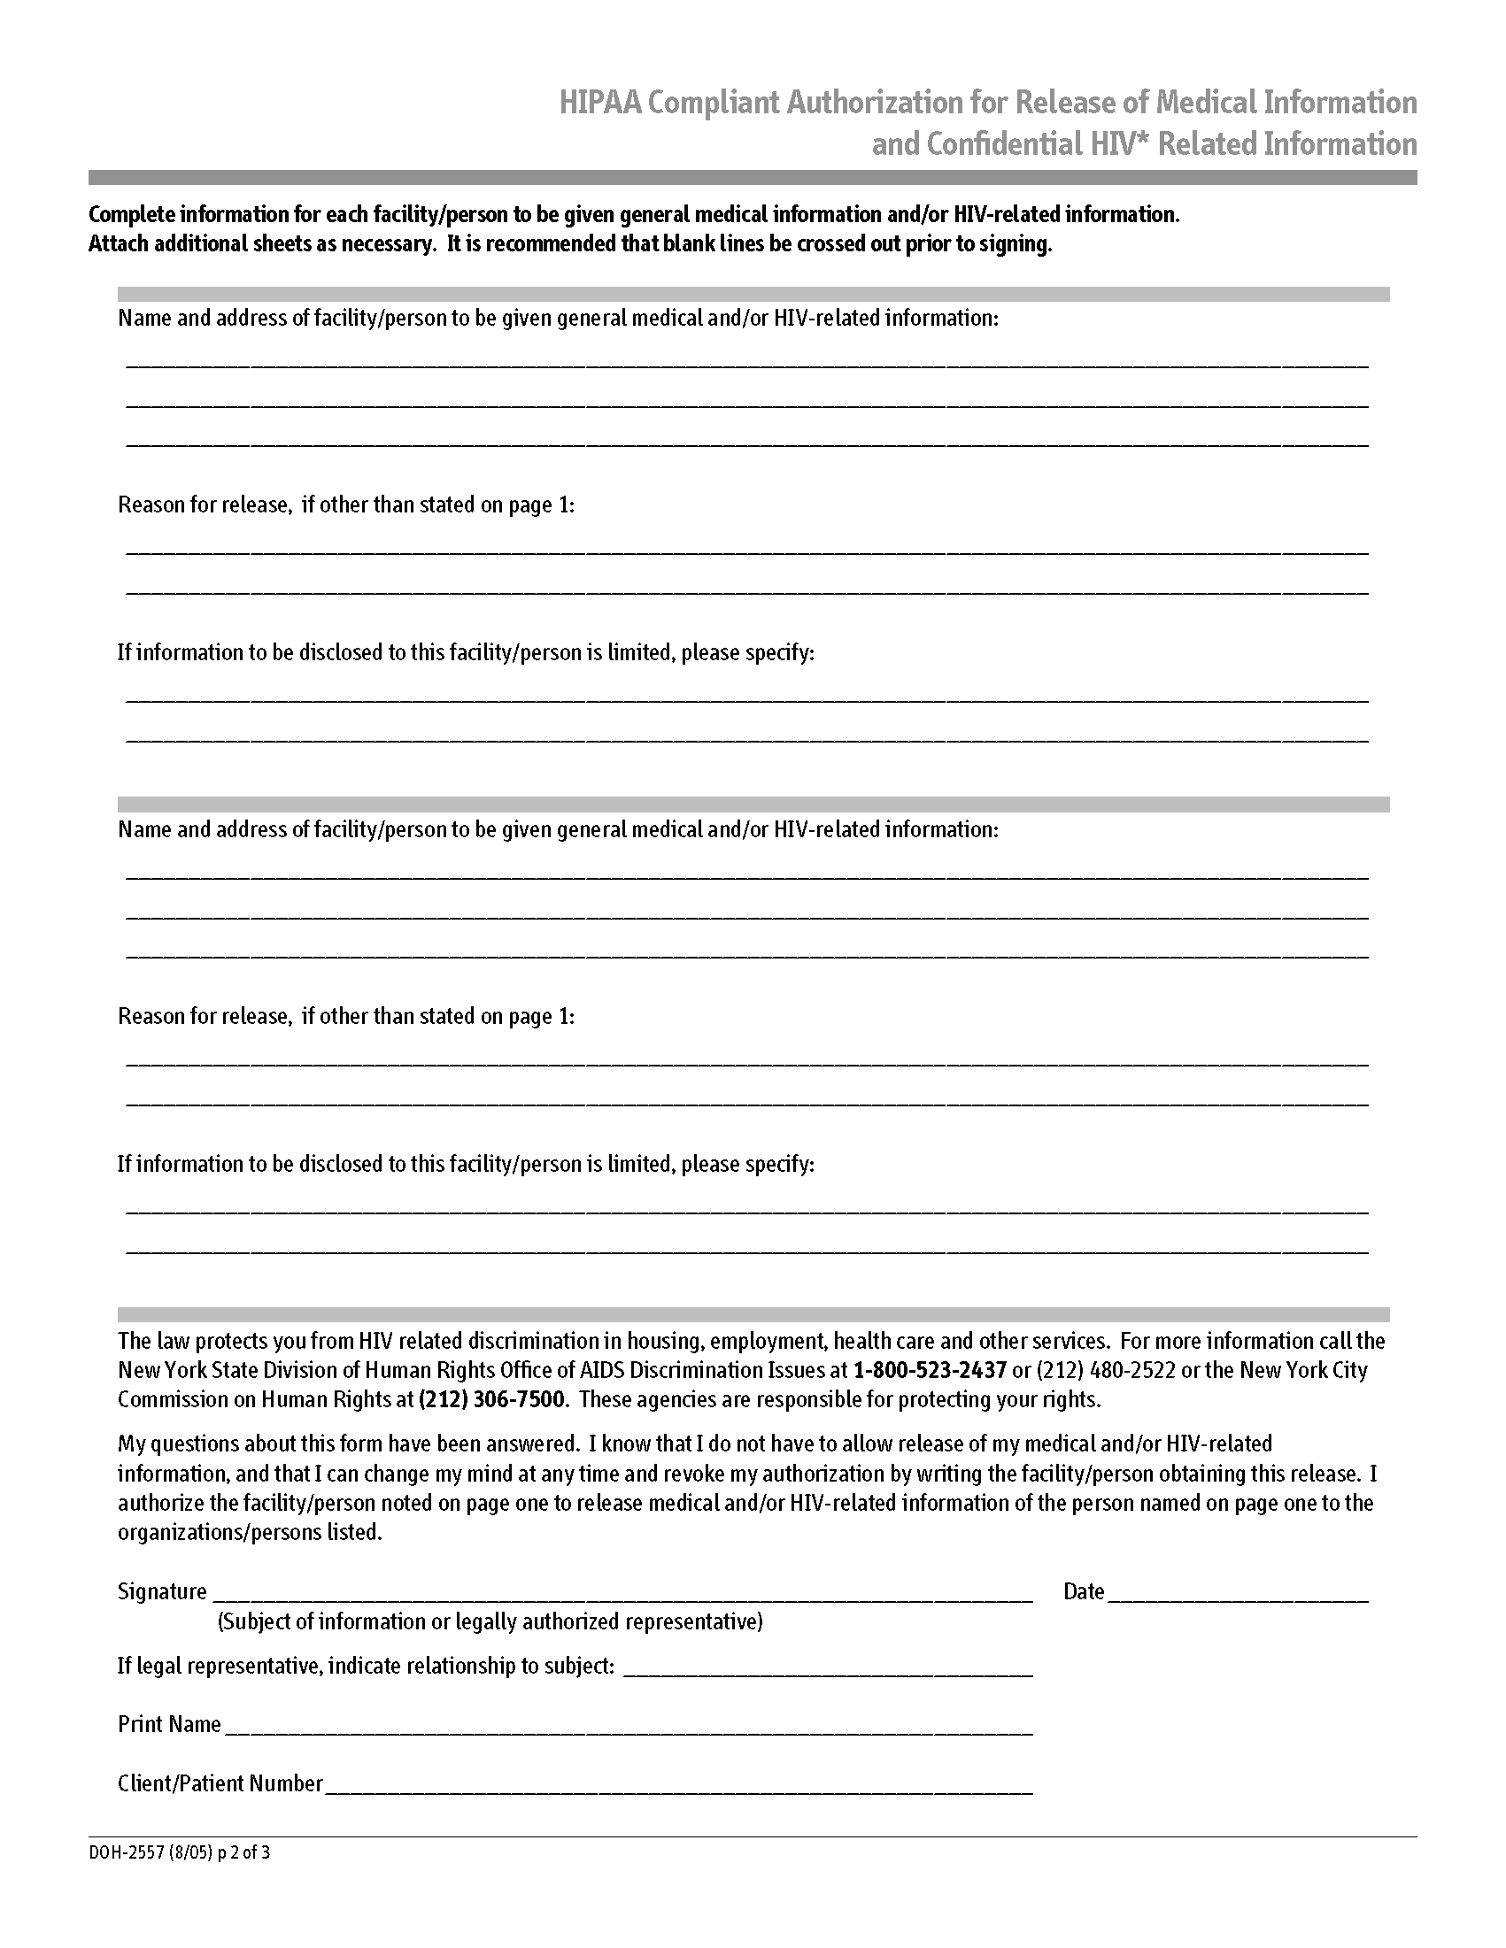
Axiom Requisition Copy Service, 2869 Jolly Rd, Okemos, Michigan 48864
(877) 886-5090 / (517) 886-4116 Fax
Order No. 01-12345 - 003

